VISVESVARAYA TECHNOLOGICAL UNIVERSITY
“JnanaSangama”, Belgaum -590014, Karnataka.


LAB REPORT on
Object Oriented Java Programming
(23CS3PCOOJ)
Submitted by Chaithanya J (1BM25CS404225-T)
in partial fulfillment for the award of the degree of
BACHELOR OF ENGINEERING
in
B.M.S. COLLEGE OF ENGINEERING
(Autonomous Institution under VTU)

BENGALURU-560019 Aug-2025 to Jan-2026
B.M.S. College of Engineering,
Bull Temple Road, Bangalore 560019
(Affiliated To Visvesvaraya Technological University, Belgaum)

Department of Computer Science and Engineering


CERTIFICATE
This is to certify that the Lab work entitled “Object Oriented Java Programming (23CS3PCOOJ)” carried out by Chaithanya J (1BM25CS404225-T), who is bonafide student of B.M.S. College of Engineering. It is in partial fulfilment for the award of Bachelor of Engineering in Computer Science and Engineering of the Visvesvaraya Technological University, Belgaum. The Lab report has been approved as it satisfies the academic requirements in respect of an Object-Oriented Java Programming (23CS3PCOOJ) work prescribed for the said degree.
Dr. Seema Patil  Associate Professor  Department of CSE, BMSCE | Dr. Kavitha Sooda  Professor & HOD  Department of CSE, BMSCE

Index
Sl.  No. | Date | Experiment Title | Page No.
1 | 23-9-25 | Develop a Java program that prints all real solutions to the quadratic equation ax2+bx+c = 0. | 4-6
2 | 14-9-25 | Develop a Java program to create a class Student with members usn, name, an array credits and an array marks. | 7-10
3 | 21-10-25 | Create a class Book which contains four members: name, author, price, num_pages. Include a constructor to set the values for the members. | 11-13
4 | 4-11-25 | Develop a Java program to create an abstract class named Shape that contains two integers and an empty method named printArea( ). | 14-16
5 | 4-11-25 | Develop a Java program to create a class Bank that maintains two kinds of account for its customers, one called savings account and the other current account. | 17-21
6 | 11-11-25 | Create a package CIE which has two classes- Student and Internals. The class Student has members like usn, name, sem. | 21-26
7 | 18-11-25 | Write a program that demonstrates handling of exceptions in inheritance tree. Create a base class called “Father” and derived class called “Son” which extends the base class. | 27-30
8 | 9-12-25 | Write a program which creates two threads, one thread displaying “BMS College of Engineering” once every ten seconds and another displaying “CSE” once every two seconds. | 30-32

Github Link:
https://github.com/ChaithanyaJ04/JAVA.git

Program 1

Develop a Java program that prints all real solutions to the quadratic equation ax2+bx+c = 0. Read in a, b, c and use the quadratic formula. If the discriminate b2-4ac is negative, display a message stating that there are no real solutions.
Code:

import java.util.Scanner;

public class QuadraticEquation
{
public static void main(String args[])
{
Scanner sc=new Scanner(System.in);
System.out.println("Enter coefficient a: ");
double a=sc.nextDouble();
System.out.println("Enter coefficient b: ");
double b=sc.nextDouble();
System.out.println("Enter coefficient c: ");
double c=sc.nextDouble();
if (a==0)
{
System.out.println("Not a quadratic equation");
do {
System.out.print("Enter a non zero value for coefficient a: ");
a=sc.nextDouble();
}
while(a==0);
}

double d=b*b-4*a*c;
if(d>0)
{
double r1=((-b) + (Math.sqrt(d)))/(2*a);
double r2=((-b) - (Math.sqrt(d)))/(2*a);
System.out.println("Roots are real and distinct");
System.out.println("Root 1: "+r1);
System.out.println("Root 2: "+r2);
}
else if (d==0)
{
double r=-b/(2*a);
System.out.println("Roots are real and equal");
System.out.println("Root 1 and root 2: "+r);
}
else
{
System.out.println("Roots are imaginary.No real solution");
}
sc.close();

}
}

OUTPUT:
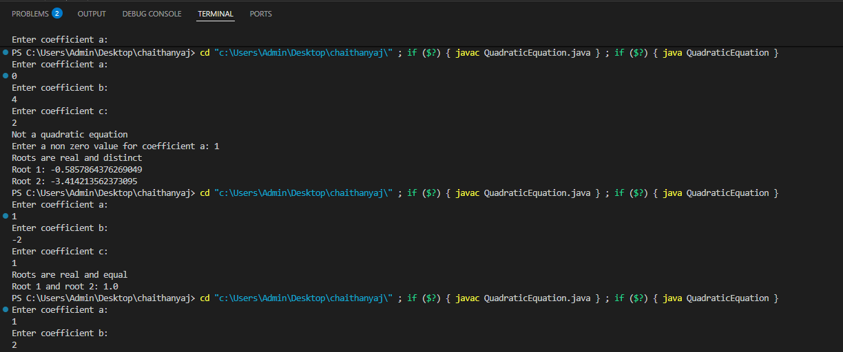
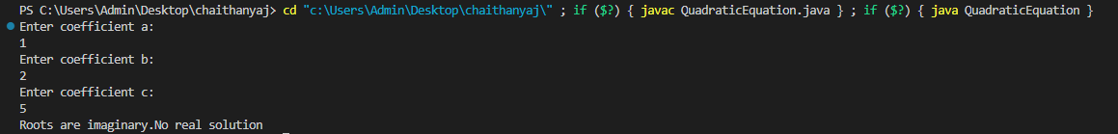

Program 2

Develop a Java program to create a class Student with members usn, name, an array credits and an array marks. Include methods to accept and display details and a method to calculate SGPA of a student.

Code:

import java.util.Scanner;

class Subject {
int subjectMarks;
double credits;
int grade;
}

class Student {
String name, usn;
double SGPA;
Scanner s;
Subject[] subject;

Student() {
s = new Scanner(System.in);
subject = new Subject[7];
for(int i = 0; i < 7; i++) {
subject[i] = new Subject();
}
}

void getStudentDetails() {
System.out.print("Enter student name: ");
name = s.nextLine();
System.out.print("Enter student USN: ");
usn = s.nextLine();
}

void getMarks() {
for(int i = 0; i < 7; i++) {
System.out.println("Subject " + (i+1) + ":");
System.out.print("Enter marks (out of 100): ");
subject[i].subjectMarks = s.nextInt();

if(subject[i].subjectMarks > 100 || subject[i].subjectMarks < 0) {
System.out.println("Invalid marks! Please enter marks between 0 and 100.");
i--;
continue;
}
System.out.print("Enter credits: ");
subject[i].credits = s.nextDouble();

subject[i].grade = (subject[i].subjectMarks / 10) + 1;
if(subject[i].grade == 11) {
subject[i].grade = 10;
}
if(subject[i].subjectMarks < 40) {
subject[i].grade = 0;
}
}
}

void computeSGPA() {
int effectiveScore = 0;
int totalCredits = 0;
for(int i = 0; i < 7; i++) {
effectiveScore += (subject[i].grade * subject[i].credits);
totalCredits += subject[i].credits;
}
SGPA = (double) effectiveScore / (double) totalCredits;
}

void display() {
System.out.println("\nStudent Details:");
System.out.println("Name: " + name);
System.out.println("USN: " + usn);
System.out.printf("SGPA: %.2f\n", SGPA);
}
}

class StudentSGPA {
public static void main(String[] args) {
Student student1 = new Student();
student1.getStudentDetails();
student1.getMarks();
student1.computeSGPA();
student1.display();
Student student2=new Student();
student2.getStudentDetails();
student2.getMarks();
student2.computeSGPA();
student2.display();
}
}

OUTPUT:
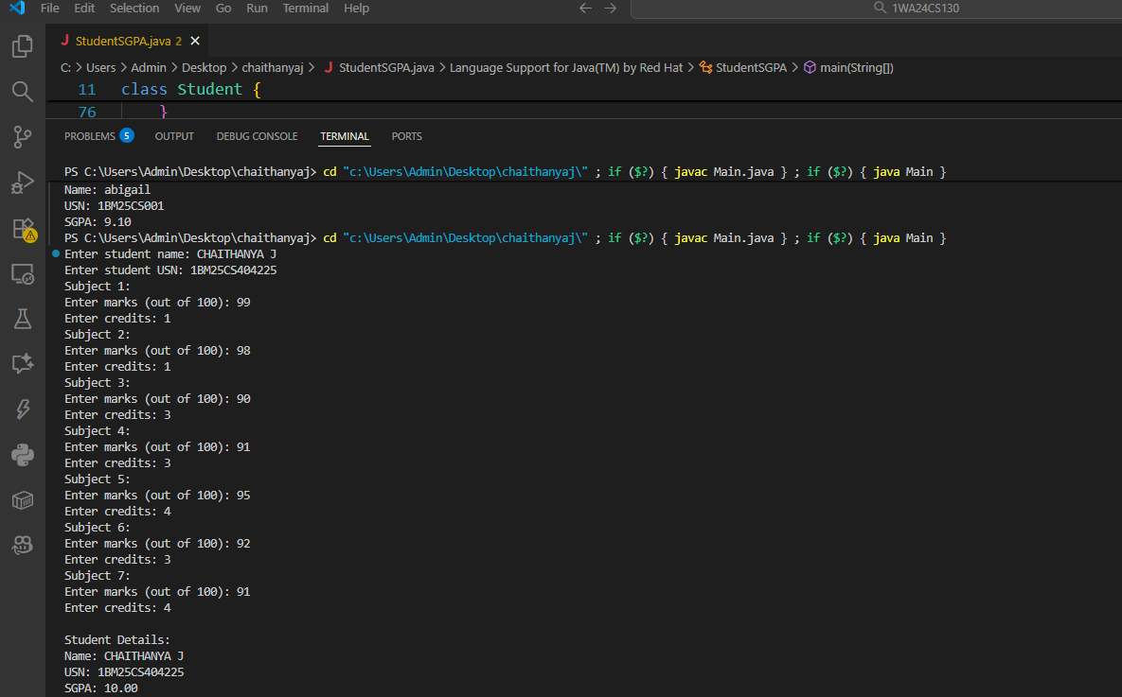
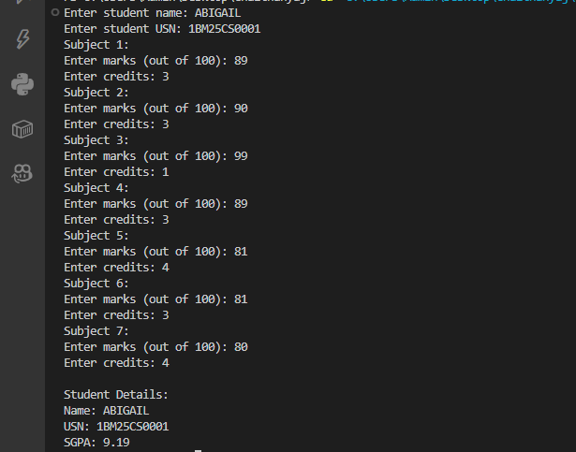

Program 3

Create a class Book which contains four members: name, author, price, num_pages. Include a constructor to set the values for the members. Include methods to set and get the details of the objects. Include a toString( ) method that could display the complete details of the book. Develop a Java program to create n book objects.

Code:

import java.util.Scanner;

class Book {
// Members
private String name;
private String author;
private double price;
private int num_pages;

// Constructor
public Book(String name, String author, double price, int num_pages) {
this.name = name;
this.author = author;
this.price = price;
this.num_pages = num_pages;
}

// Setters
public void setName(String name) { this.name = name; }
public void setAuthor(String author) { this.author = author; }
public void setPrice(double price) { this.price = price; }
public void setNumPages(int num_pages) { this.num_pages = num_pages; }

// Getters
public String getName() { return name; }
public String getAuthor() { return author; }
public double getPrice() { return price; }
public int getNumPages() { return num_pages; }

// toString method
public String toString() {
return "Book Name: " + name +
"\nAuthor: " + author +
"\nPrice: " + price +
"\nNumber of Pages: " + num_pages;
}
}

public class BookDemo {
public static void main(String[] args) {
Scanner sc = new Scanner(System.in);

System.out.print("How many books do you want to enter? ");
int n = sc.nextInt();
sc.nextLine(); // clear buffer

Book[] books = new Book[n];

for (int i = 0; i < n; i++) {
System.out.println("Enter details for Book " + (i+1) + ":");
System.out.print("Name: ");
String name = sc.nextLine();
System.out.print("Author: ");
String author = sc.nextLine();
System.out.print("Price: ");
double price = sc.nextDouble();
System.out.print("Number of Pages: ");
int num_pages = sc.nextInt();
sc.nextLine(); // clear buffer

books[i] = new Book(name, author, price, num_pages);
}

System.out.println("\nBook Details:");
for (Book b : books) {
System.out.println(b.toString());
System.out.println("----------------");
}
}
}

OUTPUT:

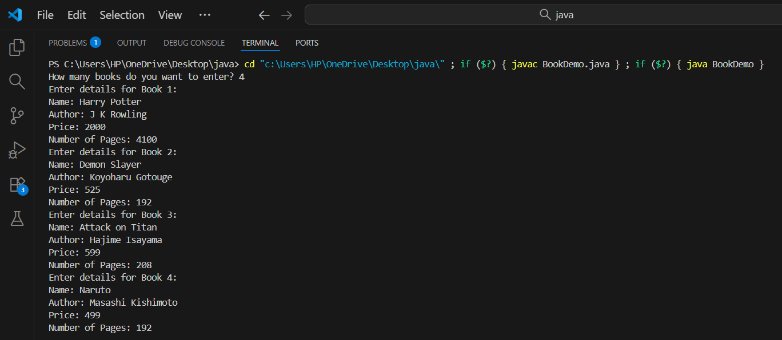
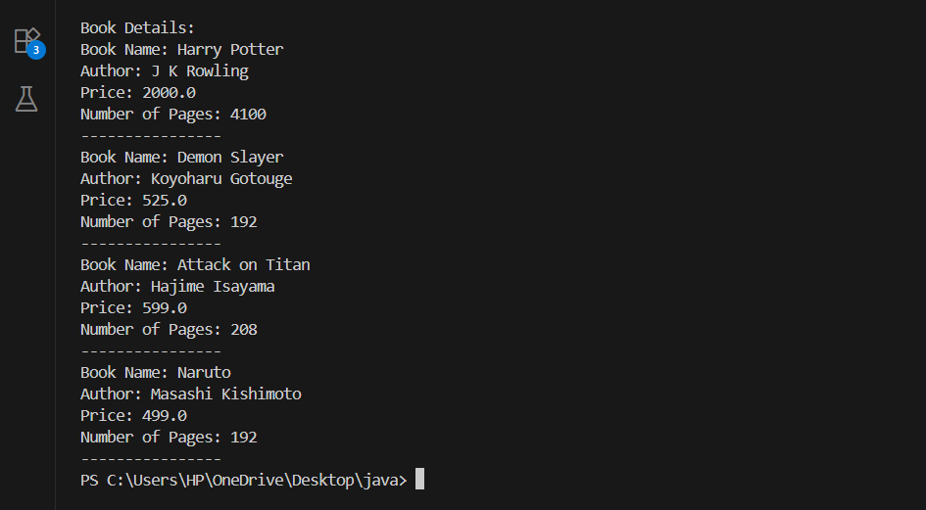

Program 4

Develop a Java program to create an abstract class named Shape that contains two integers and an empty method named printArea( ).Provide three classes named Rectangle, Triangle and Circle such that each one of the classes extends the class Shape. Each one of the classes contain only the method printArea( ) that prints the area of the given shape.

Code:

import java.util.Scanner;

class InputScanner {
Scanner sc = new Scanner(System.in);
}

abstract class Shape extends InputScanner {
int a, b;
abstract void printArea();
}

class Rectangle extends Shape {
void input() {
System.out.print("Enter length of rectangle: ");
a = sc.nextInt();
System.out.print("Enter breadth of rectangle: ");
b = sc.nextInt();
}

void printArea() {
System.out.println("Area of Rectangle = " + (a * b));
}
}

class Triangle extends Shape {
void input() {
System.out.print("Enter base of triangle: ");
a = sc.nextInt();
System.out.print("Enter height of triangle: ");
b = sc.nextInt();
}

void printArea() {
System.out.println("Area of Triangle = " + (0.5 * a * b));
}
}

class Circle extends Shape {
void input() {
System.out.print("Enter radius of circle: ");
a = sc.nextInt();
}

void printArea() {
System.out.println("Area of Circle = " + (Math.PI * a * a));
}
}

public class ShapeDemo {
public static void main(String[] args) {

Rectangle rect = new Rectangle();
Triangle tri = new Triangle();
Circle cir = new Circle();

System.out.println("\n--- Rectangle ---");
rect.input();
rect.printArea();

System.out.println("\n--- Triangle ---");
tri.input();
tri.printArea();

System.out.println("\n--- Circle ---");
cir.input();
cir.printArea();
}
}

OUTPUT:

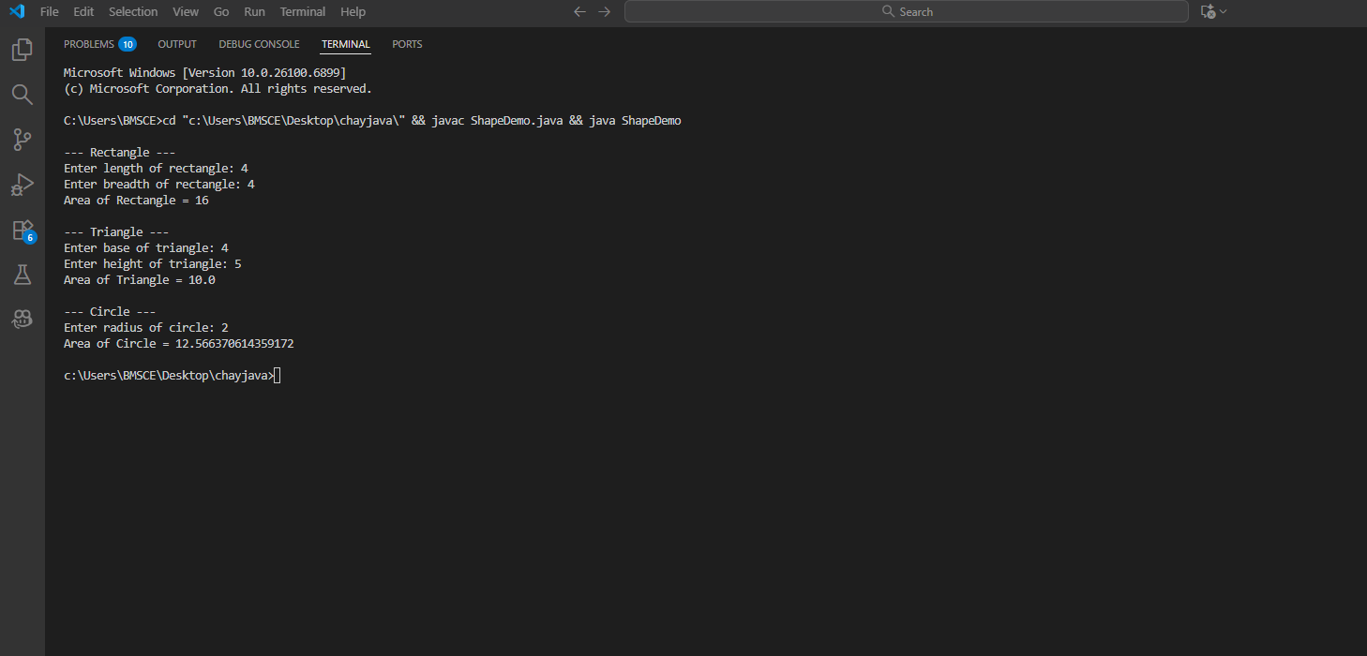

Program 5

Develop a Java program to create a class Bank that maintains two kinds of account for its customers, one called savings account and the other current account. The savings account provides compound interest and withdrawal facilities but no cheque book facility. The current account provides cheque book facility but no interest. Current account holders should also maintain a minimum balance and if the balance falls below this level, a service charge is imposed.

Code:

import java.util.Scanner;

class Account {
String customerName;
int accountNumber;
String accountType;
double balance;

Account(String name, int number, String type) {
customerName = name;
accountNumber = number;
accountType = type;
balance = 0.0;
}

void deposit(double amount) {
balance += amount;
System.out.println("Enter the type of account: " + accountType);
System.out.println("Enter the deposit amount: " + amount);
System.out.println();
}

void withdraw(double amount) {
if (balance >= amount) {
balance -= amount;
System.out.println("Enter the type of account: " + accountType);
System.out.println("Enter the withdrawal amount: " + amount);
System.out.println();
} else {
System.out.println("Insufficient balance!");
}
}

void displayAccount() {
System.out.println("Customer Name: " + customerName);
System.out.println("Account number: " + accountNumber);
System.out.println("Type of Account: " + accountType + " account");
System.out.println("Balance = " + balance);
System.out.println();
}
}

class Sav_acct extends Account {
Sav_acct(String name, int number, String type) {
super(name, number, type);
}

void computeInterest() {
double rate = 0.05; // 5%
double interest = balance * rate;
balance += interest;
System.out.println("Interest of " + interest + " added. Updated balance = " + balance);
System.out.println();
}
}

public class Bank {
public static void main(String[] args) {
Scanner sc = new Scanner(System.in);

System.out.print("Enter customer name: ");
String name1 = sc.nextLine();
System.out.print("Enter account Number: ");
int acc1 = sc.nextInt();
sc.nextLine();

System.out.print("Enter customer name: ");
String name2 = sc.nextLine();
System.out.print("Enter account Number: ");
int acc2 = sc.nextInt();
sc.nextLine();

Sav_acct s1 = new Sav_acct(name1, acc1, "Savings");
Sav_acct s2 = new Sav_acct(name2, acc2, "Savings");

int choice;
do {
System.out.println("-----MENU-----");
System.out.println("1. Deposit");
System.out.println("2. Withdraw");
System.out.println("3. Compute interest for SavingsAccount");
System.out.println("4. Display account details");
System.out.println("5. Exit");
System.out.print("Enter your choice: ");
choice = sc.nextInt();

switch (choice) {
case 1:
System.out.print("Enter account number: ");
int ac = sc.nextInt();
System.out.print("Enter amount to deposit: ");
double damt = sc.nextDouble();
if (ac == s1.accountNumber)
s1.deposit(damt);
else if (ac == s2.accountNumber)
s2.deposit(damt);
else
System.out.println("Invalid account number!");
break;

case 2:
System.out.print("Enter account number: ");
ac = sc.nextInt();
System.out.print("Enter amount to withdraw: ");
double wamt = sc.nextDouble();
if (ac == s1.accountNumber)
s1.withdraw(wamt);
else if (ac == s2.accountNumber)
s2.withdraw(wamt);
else
System.out.println("Invalid account number!");
break;

case 3:
System.out.print("Enter account number: ");
ac = sc.nextInt();
if (ac == s1.accountNumber)
s1.computeInterest();
else if (ac == s2.accountNumber)
s2.computeInterest();
else
System.out.println("Invalid account number!");
break;

case 4:
System.out.print("Enter account number: ");
ac = sc.nextInt();
if (ac == s1.accountNumber)
s1.displayAccount();
else if (ac == s2.accountNumber)
s2.displayAccount();
else
System.out.println("Invalid account number!");
break;

case 5:
System.out.println("Exiting...");
break;

default:
System.out.println("Invalid choice!");
}

} while (choice != 5);

sc.close();
}
}

OUTPUT:
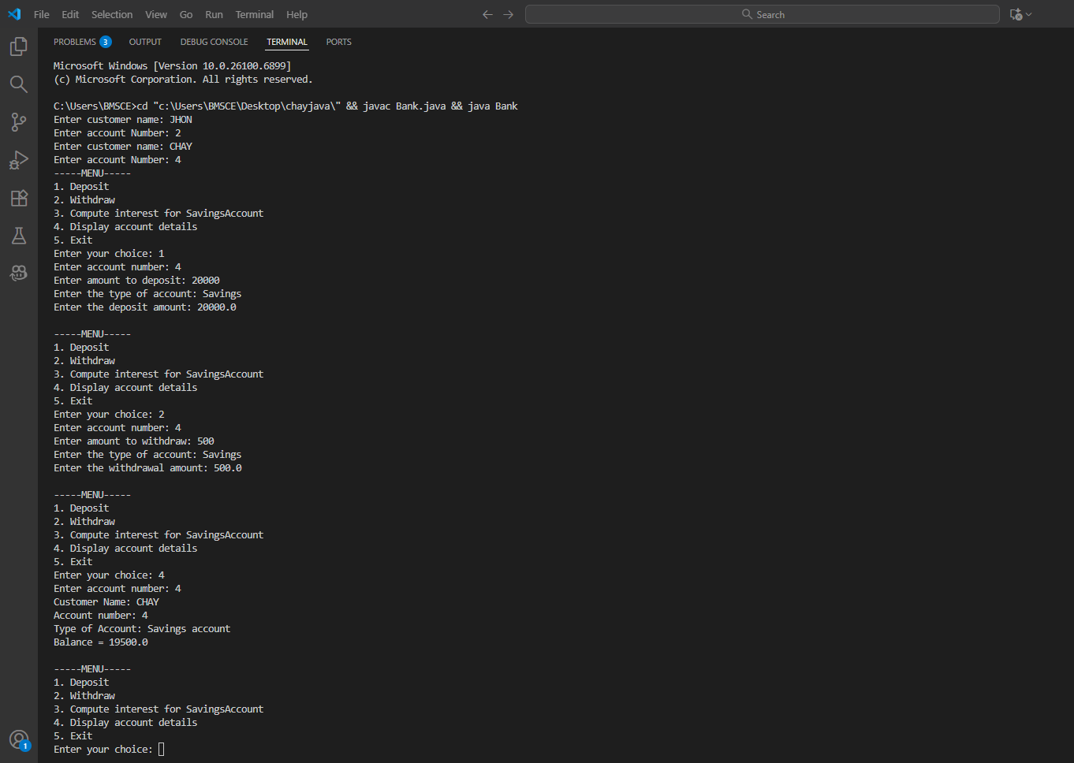

Program 6

Create a package CIE which has two classes- Student and Internals. The class Student has members like usn, name, sem. The class Internals derived from Student has an array that stores the internal marks scored in five courses of the current semester of the student. Create another package SEE which has the class External which is a derived class of Student. This class has an array that stores the SEE marks scored in five courses of the current semester of the student. Import the two packages in a file that declares the final marks of n students in all five courses.
Code:
CIE
Student
package CIE;

public class Student {
public String usn;
public String name;
public int sem;

public Student(String usn, String name, int sem) {
this.usn = usn;
this.name = name;
this.sem = sem;
}

public void display() {
System.out.println("USN: " + usn + " | Name: " + name + " | Semester: " + sem);
}
}

Internals

package CIE;

import java.util.Scanner;

public class Internals extends Student {
public int[] internalMarks = new int[5];

public Internals(String usn, String name, int sem) {
super(usn, name, sem);
}

public void getMarks() {
Scanner sc = new Scanner(System.in);
System.out.println("Enter Internal Marks for 5 subjects:");
for (int i = 0; i < 5; i++) {
System.out.print("Subject " + (i + 1) + ": ");
internalMarks[i] = sc.nextInt();
}
}
}

SEE
External
package SEE;

import CIE.Student;
import java.util.Scanner;

public class External extends Student {
public int[] seeMarks = new int[5];

public External(String usn, String name, int sem) {
super(usn, name, sem);
}

public void getMarks() {
Scanner sc = new Scanner(System.in);
System.out.println("Enter SEE Marks for 5 subjects:");
for (int i = 0; i < 5; i++) {
System.out.print("Subject " + (i + 1) + ": ");
seeMarks[i] = sc.nextInt();
}
}
}

Main
import CIE.*;
import SEE.*;
import java.util.Scanner;

public class FinalMarks {
public static void main(String[] args) {
Scanner sc = new Scanner(System.in);

System.out.print("Enter number of students: ");
int n = sc.nextInt();

Internals[] internal = new Internals[n];
External[] external = new External[n];

for (int i = 0; i < n; i++) {
System.out.println("\nEnter details of Student " + (i + 1));
System.out.print("USN: ");
String usn = sc.next();
System.out.print("Name: ");
String name = sc.next();
System.out.print("Semester: ");
int sem = sc.nextInt();

internal[i] = new Internals(usn, name, sem);
internal[i].getMarks();

external[i] = new External(usn, name, sem);
external[i].getMarks();
}

System.out.println("\n----- Final Marks of Students -----");
for (int i = 0; i < n; i++) {
internal[i].display();
System.out.println("Final Marks in 5 Subjects:");
for (int j = 0; j < 5; j++) {
int finalMarks = internal[i].internalMarks[j] + (external[i].seeMarks[j] / 2);
System.out.println("Subject " + (j + 1) + ": " + finalMarks);
}
System.out.println();
}
}
}

OUTPUT:
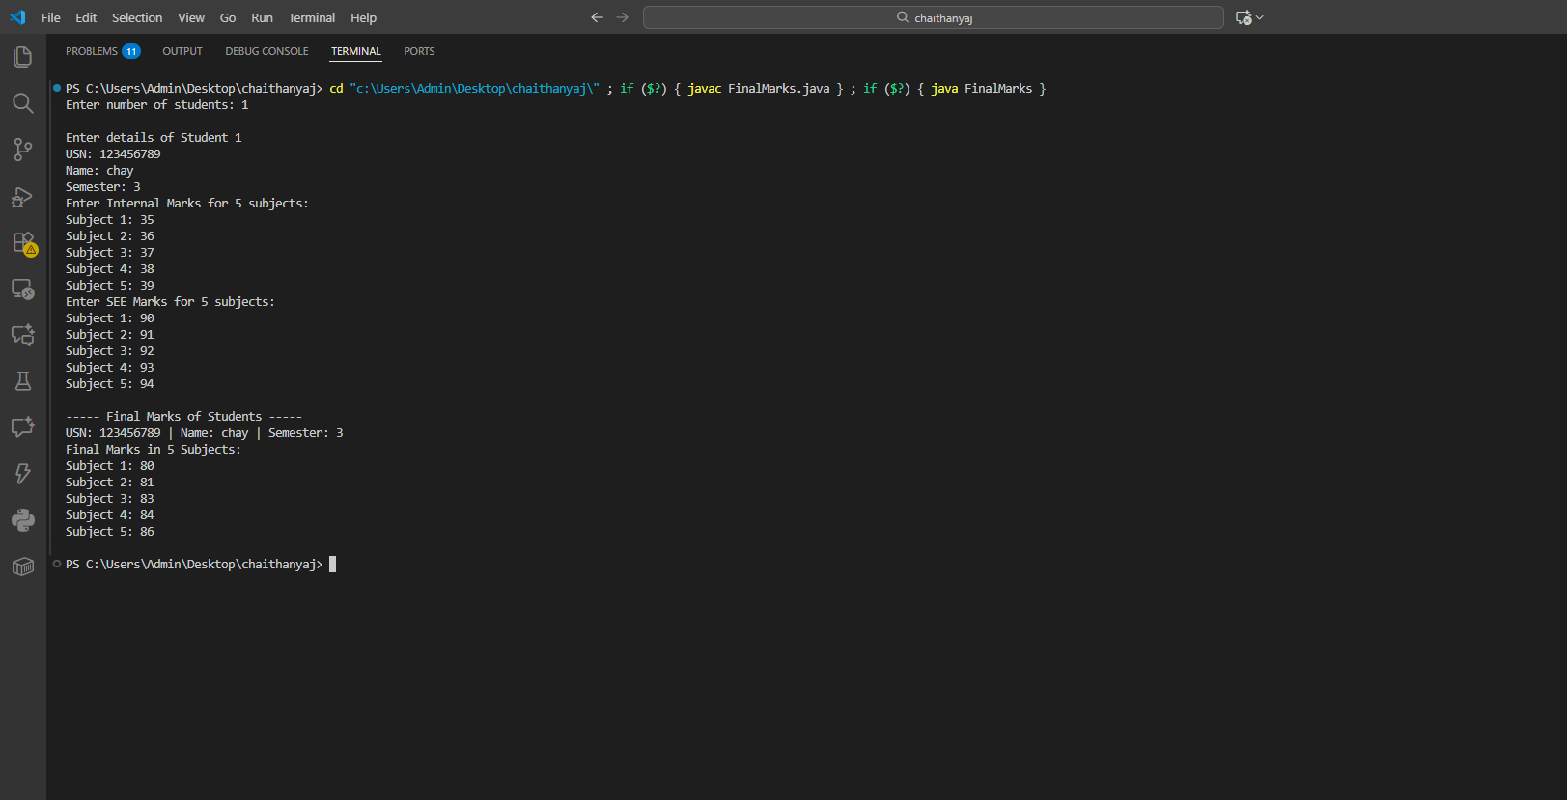

Program 7
Write a program that demonstrates handling of exceptions in inheritance tree. Create a base class called “Father” and derived class called “Son” which extends the base class. In Father class, implement a constructor which takes the age and throws the exception WrongAge( ) when the input age<0. In Son class, implement a constructor that cases both father and son’s age and throws an exception if son’s age is >=father’s age.
Code:
import java.util.Scanner;

// Custom Exception
class WrongAge extends Exception {
WrongAge() {
super("Wrong Age Entered");
}

WrongAge(String msg) {
super(msg);
}
}

// Father class
class Father {
int fatherAge;

Father(int age) throws WrongAge {
if (age < 0) {
throw new WrongAge("Father's age cannot be negative");
}
fatherAge = age;
}

void display() {
System.out.println("Father's Age: " + fatherAge);
}
}

// Son class extending Father
class Son extends Father {
int sonAge;

Son(int fatherAge, int sonAge) throws WrongAge {
super(fatherAge);

if (sonAge < 0) {
throw new WrongAge("Son's age cannot be negative");
}
if (sonAge >= fatherAge) {
throw new WrongAge("Son's age cannot be greater than or equal to father's age");
}

this.sonAge = sonAge;
}

void display() {
super.display();
System.out.println("Son's Age: " + sonAge);
}
}

// Main class
public class prg7 {
public static void main(String[] args) {
Scanner sc = new Scanner(System.in);

try {
System.out.print("Enter Father's Age: ");
int fAge = sc.nextInt();

System.out.print("Enter Son's Age: ");
int sAge = sc.nextInt();

Son obj = new Son(fAge, sAge);

obj.display();

} catch (WrongAge e) {
System.out.println("Exception: " + e.getMessage());
}
}
}

OUTPUT:
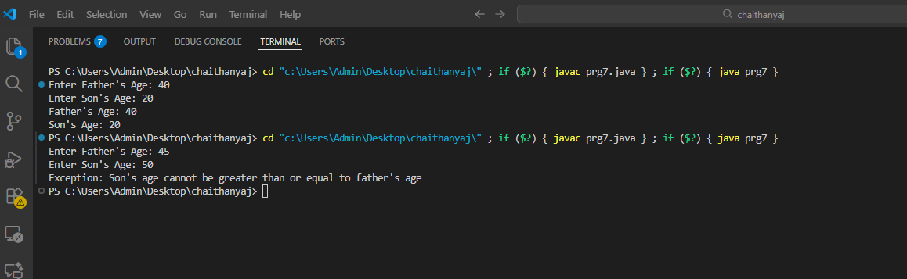

Program 8
Write a program which creates two threads, one thread displaying “BMS College of Engineering” once every ten seconds and another displaying “CSE” once every two seconds.
Code:
class CollegeThread extends Thread {
public void run() {
try {
for (int i = 0; i < 5; i++) { // print 5 times
System.out.println("BMS College of Engineering");
Thread.sleep(10000); // 10 seconds
}
} catch (InterruptedException e) {
e.printStackTrace();
}
}
}

class CSEThread extends Thread {
public void run() {
try {
// Since CSE prints every 2 seconds and BMS every 10 seconds,
// we need 5 CSE prints for each 1 BMS print → total 25 prints
for (int i = 0; i < 25; i++) {
System.out.println("CSE");
Thread.sleep(2000); // 2 seconds
}
} catch (InterruptedException e) {
e.printStackTrace();
}
}
}

public class Main {
public static void main(String[] args) {
CollegeThread t1 = new CollegeThread();
CSEThread t2 = new CSEThread();

t1.start();
t2.start();
}
}

OUTPUT:

